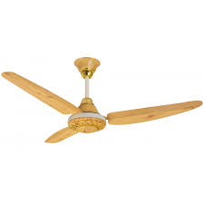

Super Asia

* Model: SA245
* Capacity: 8 Kg
* Double Action Pulsator
* White Color
* **Rs.20,999**